Ideation Phase
Empathize & Discover

Team ID | LTVIP2026TMIDS24872
Project Name | Educational Organisation using ServiceNow
Maximum Marks | 4 Marks

Empathy Map :
User Profile for Empathy Mapping
- Persona: School Administrator / Admissions Officer.
- Context: Responsible for handling student admissions, maintaining academic records, and managing performance data within the institution.
- Current Situation: Currently dependent on manual and paper-based systems, which lead to delays, redundancy, and frequent errors in record management.
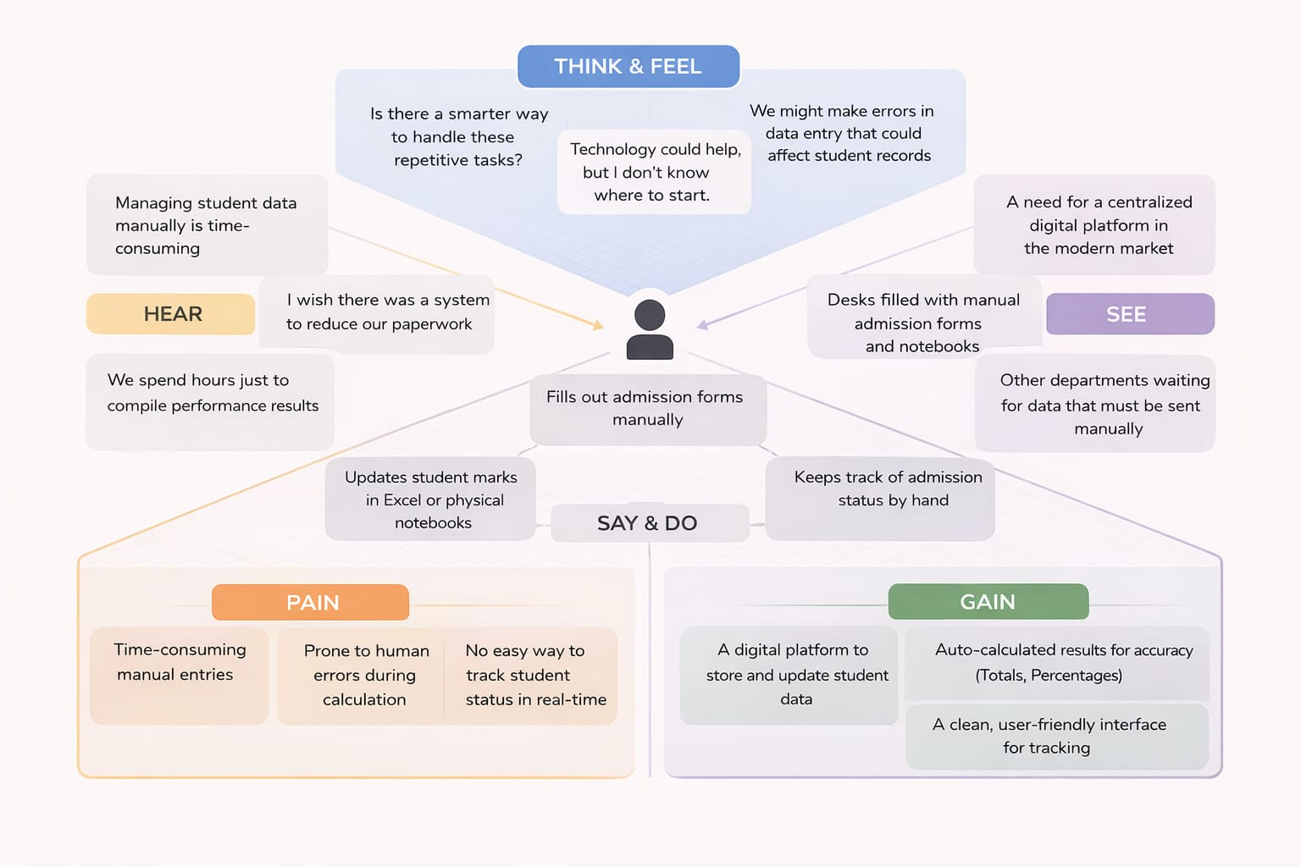
Educational Organisation Using ServiceNow

